Operation Manual

**Flux-tool cleaning system**

# PC Software

Production : ATK5 EE

S/W Engineer : Hyun-su Park

# Run a program

Double-click the FluxTool_CleanerSystem_ATV.exe icon on the desktop to run it

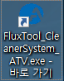

# Log-in

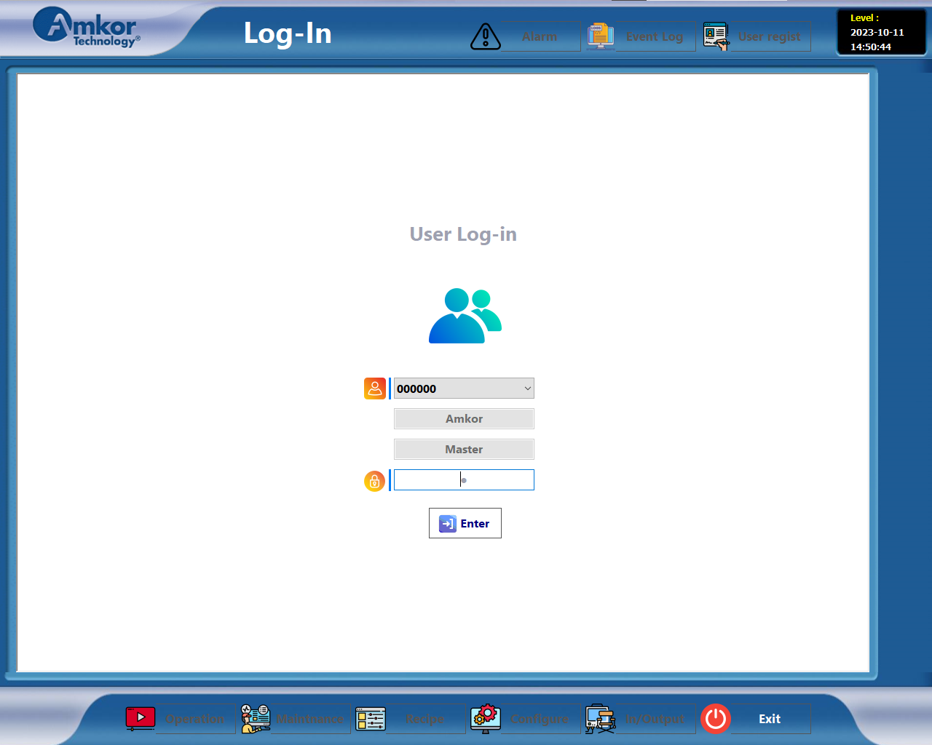

Log in after entering ID and password

* Default ID : 000000
* Default Password : 1

# Operation

# 

**1**

# Close the front door of the equipment and press the start button

# If the following window opens, press the check button

# 

# 

**2**

# Select the Recipe file and press the OK button

# If you want to stop the process, press the stop button

# Ch1, Ch2, Ch3 The same GUI and SEQ

1. 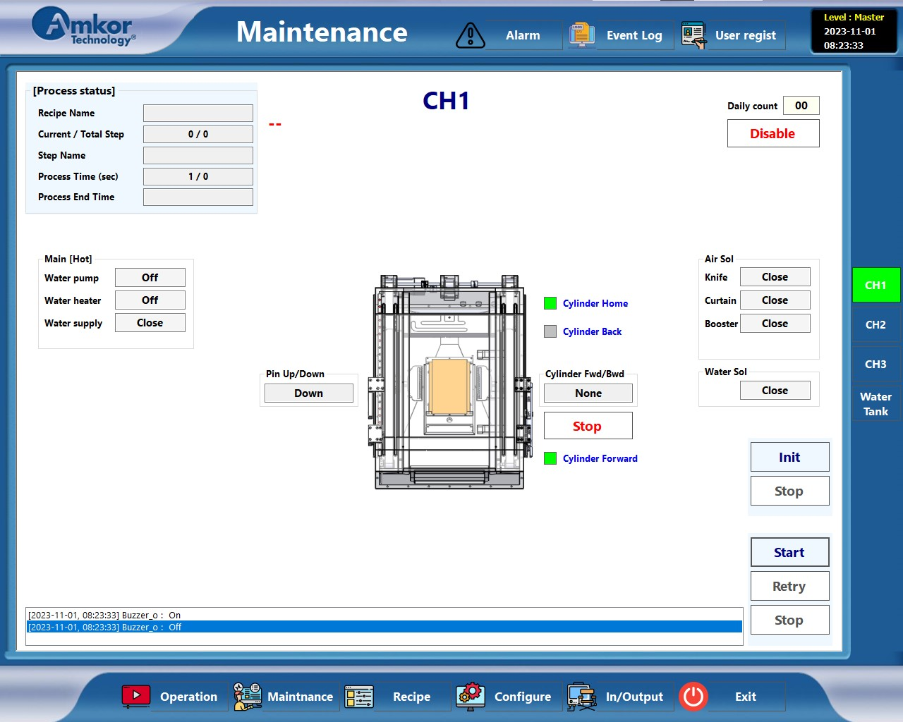 **Maintenance**

**1**

If you press the Maintenance button, you will see the screen above

The process can be carried out the same as the "Operation" screen

1. Individual I/O operations are possible

However, it is impossible to operate during the process

1. 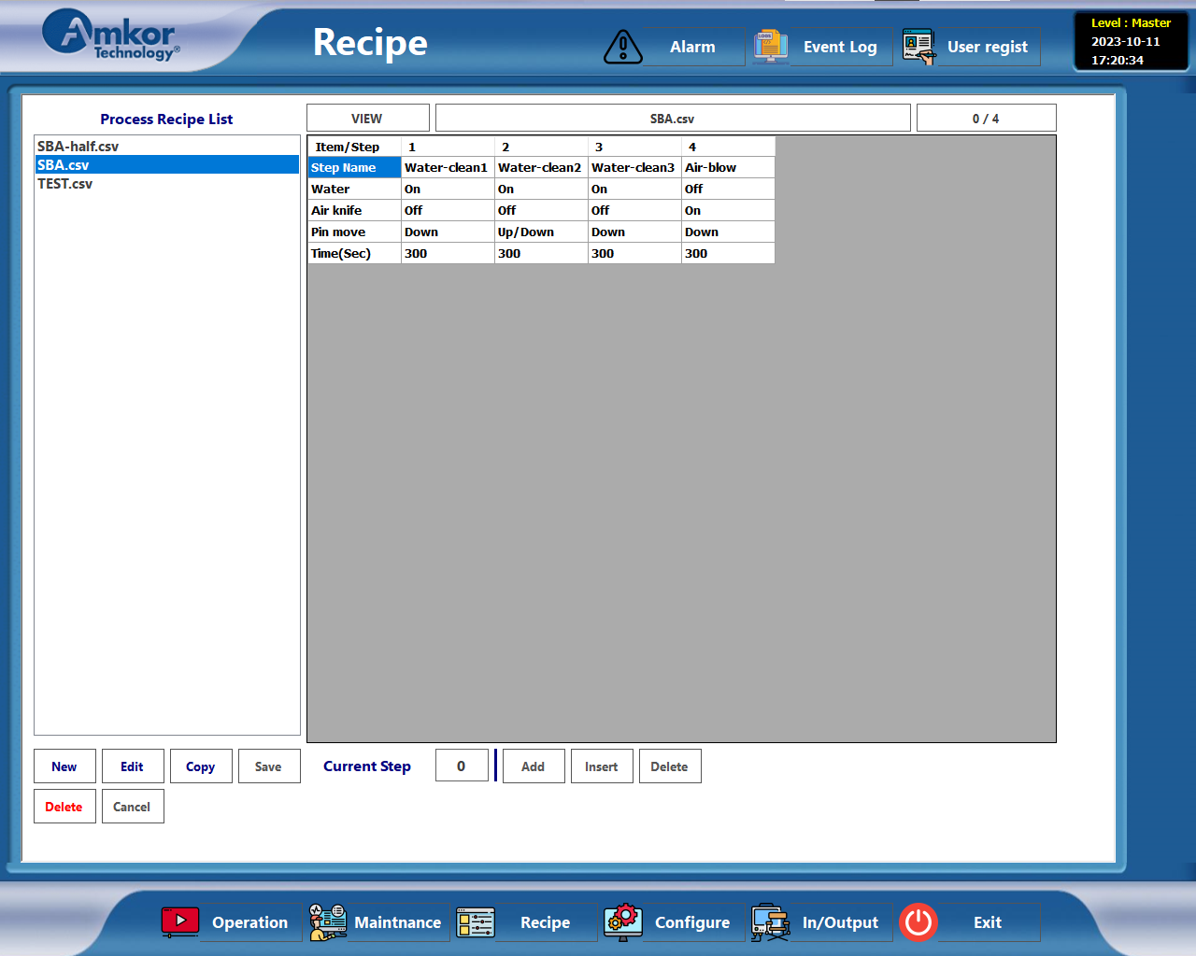**Recipe**

**3**

**2**

**1**

* 1. New / Edit / Copy / Save / Delete / Cancel button
* New : Create a new Recipe file
* Edit : Modifying Recipe Content
* Copy : Copy Recipe File
* Save : Create or modify Recipe and save it as a file (csv file)
* Delete : Delete Recipe File
* Cancel : Cancel creating or modifying Recipe
  1. Add / Insert / Delete
* Ability to add, insert, or delete each step in Recipe
* One recipe can be created up to 50 steps in total
  1. Recipe Item
* Water : Whether to use water
* Air knife : Whether to use dry air
* Pin move : Whether to use pin

1. Up : Keep Pin up
2. Down : Keep Pin down
3. Up/Down : Repeat Pin up/down every 3 seconds

* Time : Each step process time (sec)

1. 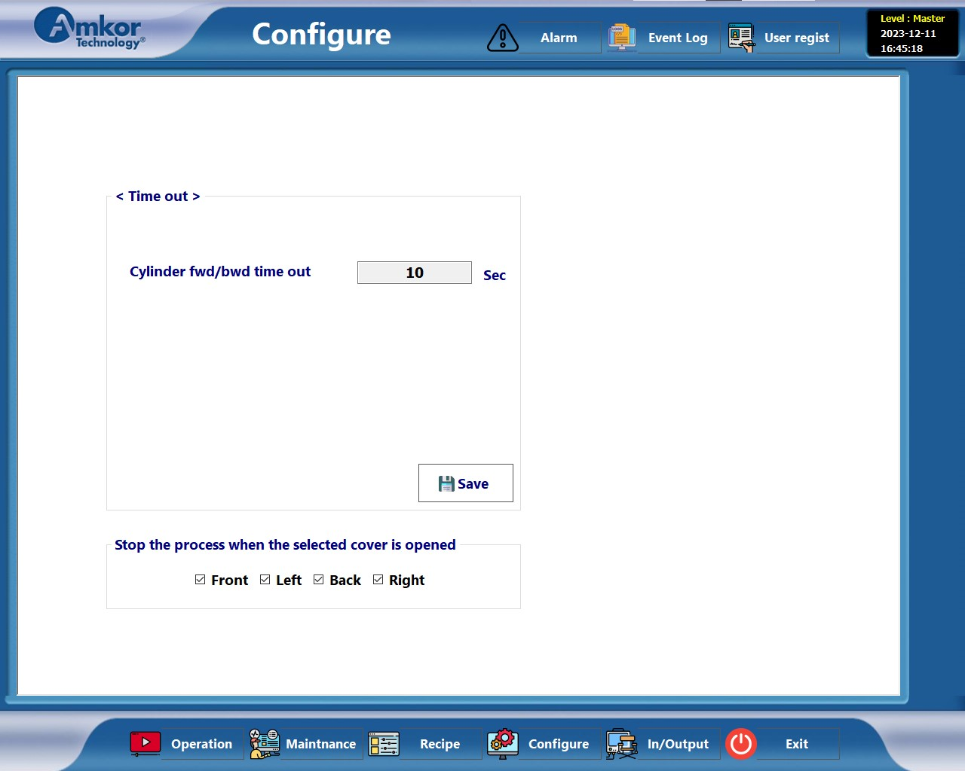**Configure**

* <Time out>
* Cylinder fwd/bwd time out : Alarm if it does not operate within the set time when moving the cylinder
* Stop the process when the selected cover is opened

1. 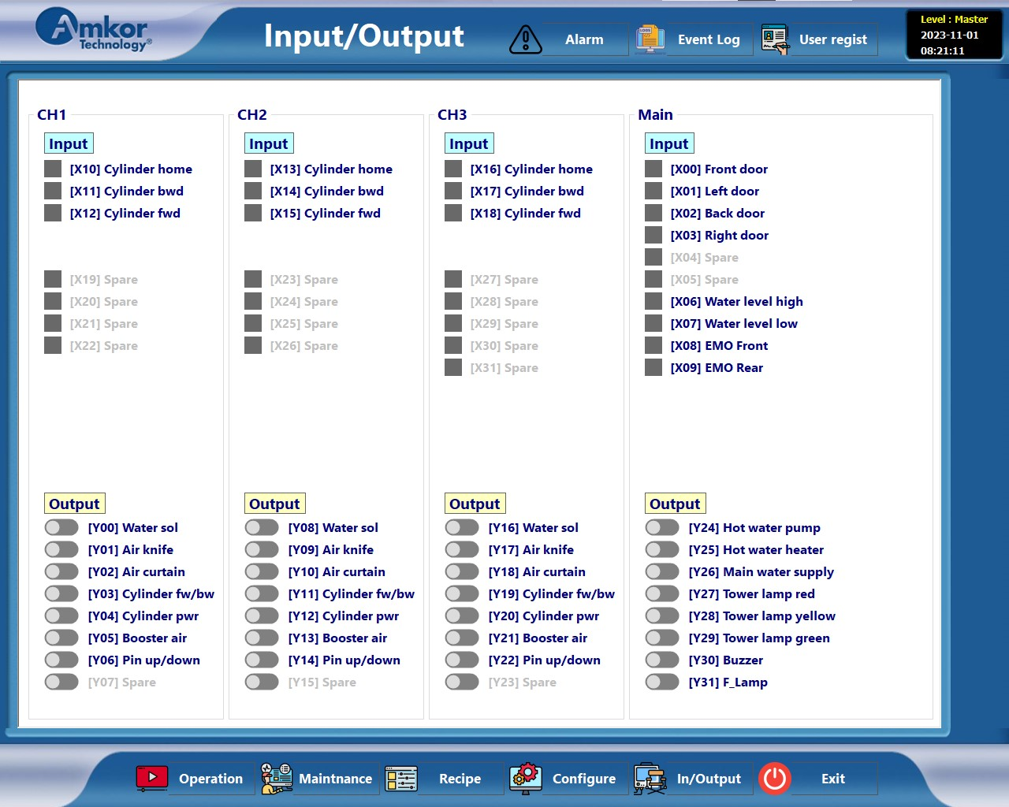**In/Output**

Check I/O control and status

1. 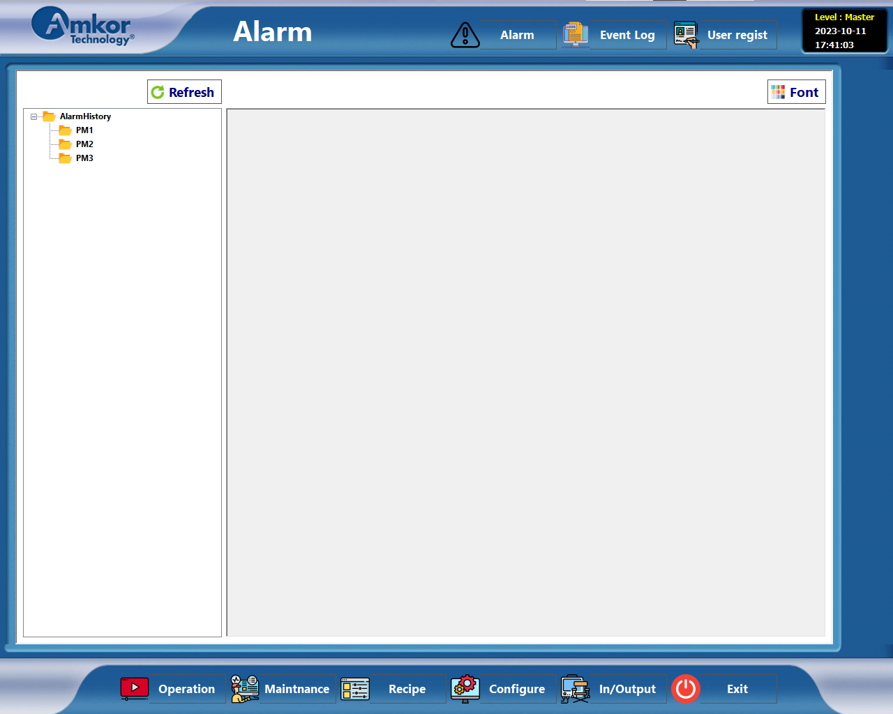**Alarm**

Alarm history by channel

* Alarm list
  1. Code. 1002 : Failed to read recipe file
* Alarm when the Recipe file fails to be loaded during the process
  1. Code. 1005 : Cylinder forward time out
* Alarm if cylinder operation fails to reach forward position within set time
  1. Code. 1006 : Cylinder backward time out
* Alarm if cylinder operation fails to reach backward position within set time
  1. Code. 1007 : Cylinder home time out
* Alarm if cylinder operation fails to reach home position within set time

1. 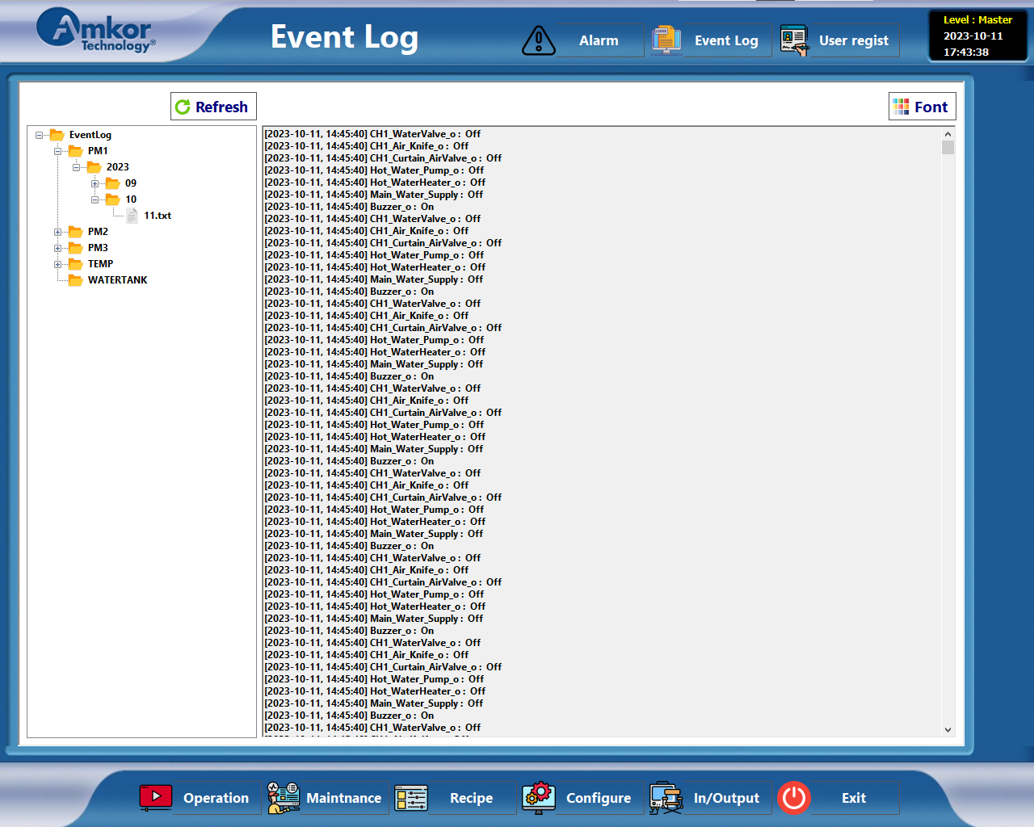**Event Log**

Event history by channel (year/month/date)

1. **User regist**

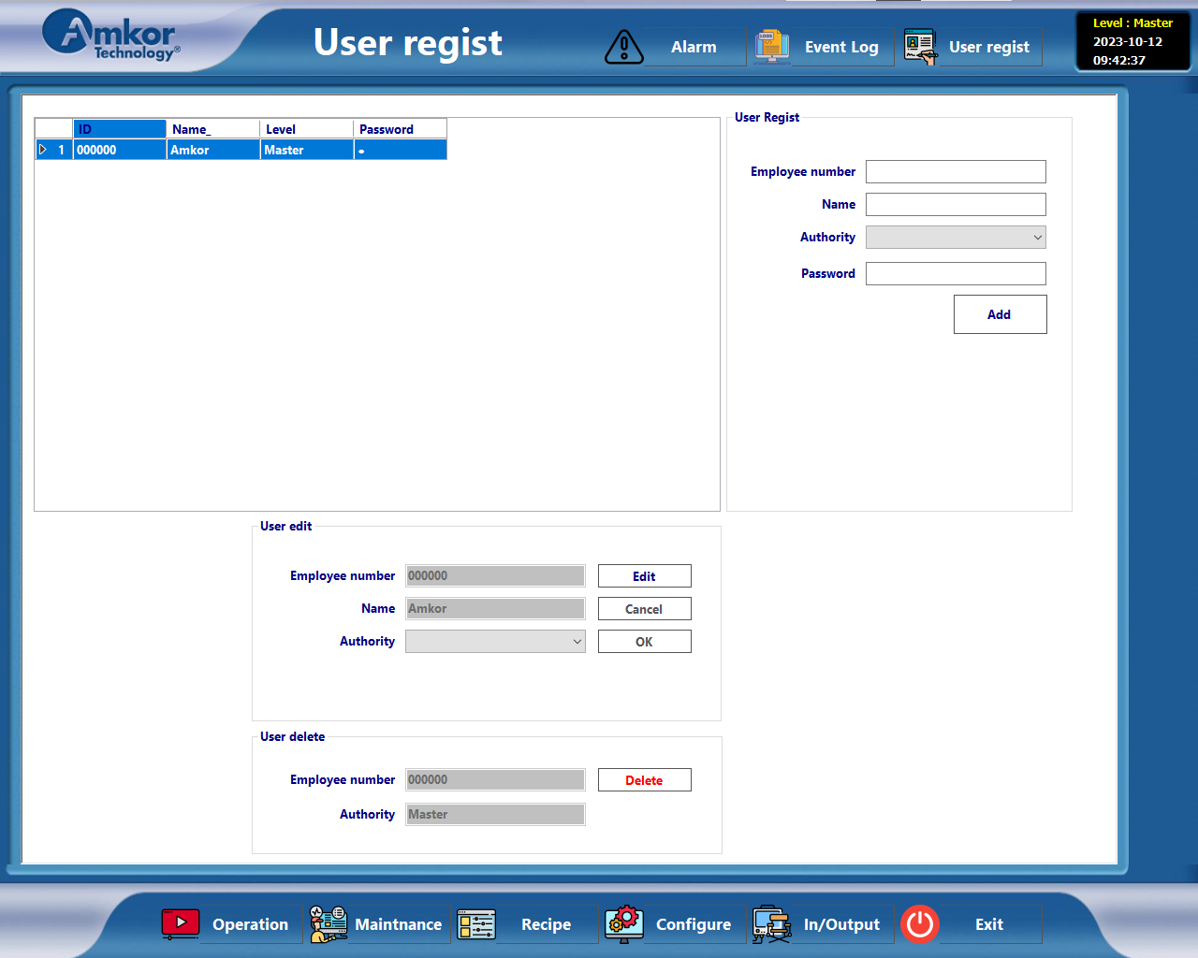

New User registration and modify, delete function

* User regist
* Employee number : Employee number or unique numbers
* Name : Name
* Authority : Setting permissions (screen access permission)
* Password : Password
* User edit
* Modify existing registered user information
* User delete
* Delete registered users